in
Disclaimer: I DO NOT claim or guarantee whether the answer written here is 100% accurate. If you feel something is not accurate or out-of-order or want to contribute, it will be a great help, if you let me know. Question which are crossed refers to the repeated question which has been answered already but this rule hasn’t been applied to all repeated question. Use Chrome to read this PDF properly. All question are from Pokhara University board exam papers of BCA.
Author: Pranav Bhattarai
ALP = Assembly Language Programming
2023 Fall
1 a) How do you know whether the given chip is a microprocessor or microcontroller?
1 b) Explain the Program Counter of SAP-I computer. How does adder/subtractor perform in SAP-I computer.
2 a) Write a program to perform (3x4-B)₁₆ in SAP-I.
2 b) Compare SAP I with SAP II. Explain flags of SAP II along with set and reset condition.
3 a) Show the machine cycle status with control signals. Explain the Instruction Cycle.
3 b) Explain the Addressing Modes of 8085 with necessary examples.
4 a) Six byte are stored in memory location starting from 3000H. Add all the data bytes, save any carry generated while adding the data bytes. Display entire sum at two output ports and store total carry in 3050H and sum in 3051H.
4 b) Explain the Direct Memory Access (DMA) operation with diagram. List out the application of DMA.
5 a) Draw block diagram of 8255A interface. Show control word of various Ports with examples.
5 b) Differentiate between Synchronous and Asynchronous Serial communication? How two computers are connected without modem?
6 a) Write a program in 8086 ALP to display the string “STUDY IN NEPAL” in reverse order.
6 b) What is pipelining in 8086 microprocessor? Explain instruction set of 8086.
7. Write short notes (Any two):
a. 8085 Interrupts
b. IEEE 488-1978 General Purpose Interface Standard
c. IO Write
2023 Spring

1 a) Define microprocessor? How it is different from microcontroller? Explain.
1 b) Explain architecture of SAP-I with figure.
2 a) Write an ALP to perform (17+23-44)₁₀ in SAP-I. Also write the same in machine language.
2 b) Explain flags and bidirectional register of SAP-2 in brief.
3 a) Draw timing dirgarm of ADD C. Discuss in brief.
3 b) Explain the instruction set of 8085.
4 a) Draw the internal architecture of 8085 microprocessor unit. Explain about various flags used.

4 b) Write an ALP in 8085 to add two 32-bits number and store the result.
; Load first 32-bit number (using HL and DE register pairs)
LHLD 2000H ; Lower 16 bits of first number (in HL)
LXI D, 2002H ; Load address of higher 16 bits of first number into DE
MOV E, M ; Higher 16 bits of first number (in E)

; Load second 32-bit number (using BC and HL register pairs)
LHLD 2004H ; Lower 16 bits of second number (in HL)
LXI D, 2006H ; Load address of higher 16 bits of second number into DE
MOV D, M ; Higher 16 bits of second number (in D)

; Add lower 16 bits
DAD B ; Add lower 16 bits of first and second numbers
SHLD 8000H ; Store the result (lower 16 bits) in memory

; Add higher 16 bits (including the carry)
DAD D ; Add higher 16 bits with carry

; Store the result (higher 16 bits)
SHLD 8002H ; Store in memory

HLT ; Halt program execution
Ans:

(Bard + GPT4-Turbo) ----------------------------------------->

Some things to know to understand the code:
- LHLD
Load HL pair using Direct addressing from memory location
- LXI // Load Register Pair with Immediate
It's used to load a 16-bit value directly into one of the 8085's register pairs (BC, DE, HL, or SP).

- DAD // Double Add
It’s an instruction used to add the contents of a register pair to the HL register pair.

- SHLD // Store HL pair using Direct addressing
It's used to store the contents of the HL register pair (16 bits) into a memory location specified by a 16-bit address.

SH: Represents "Store" operation for the HL pair.
LD: Represents "load" (indirectly referring to storing the contents of the register).

5 a) Define instruction and machine cycle. Draw and explain timing diagram for execution of MVI A, 32H.
5 b) What is interfacing? Draw and explain the block diagram of 8255A.

6 a) Explain RS 232 standard? Explain the mode of comunication.
=>
The term “mode of communication” typically refers to the method of data transfer between devices. Here are the common modes of communication in microprocessors:

Simplex Mode: In this mode, the communication is unidirectional, meaning only one of the two devices on a link can transmit, the other can only receive. An example of this is a keyboard and a traditional monitor.

Half-Duplex Mode: In half-duplex mode, each station can both transmit and receive, but not at the same time. When one device is sending, the other can only receive, and vice versa. An example of this is a walkie-talkie.

Full-Duplex Mode: In full-duplex mode, both stations can transmit and receive simultaneously. This mode requires either two physically separate transmission paths, one for sending and the other for receiving, or a method to share the capacity of the link between signals going in both directions.

These modes are crucial in the design of buses and networks to allow communication to occur between individual devices that are interconnected. They are used in various communication devices like the keyboard, mouse, printer, etc., which need to interface with the microprocessor.

6 b) Write a program in 8086 ALP to display the string “MICROPROCESSOR IS INTERESTING”.
.MODEL SMALL
.STACK 100H

.DATA
MSG DB 'Microprocessor is INTERESTING$' ; String to be displayed

.CODE
MAIN PROC
LEA DX, MSG ; Load the address of the string into DX
MOV AH, 09H ; BIOS interrupt for string output
INT 21H ; Call the interrupt

MOV AH, 4CH ; BIOS interrupt for program termination
INT 21H ; Call the interrupt

MAIN ENDP
END MAIN

7. Write short notes on: (Any two)
a) IO Read
b) SAP 2 in comparison with SAP I
c) IEEE 488 – 1978 General Purpose Interface Standard
2022 Fall

1 a) Explain microprocessor evolution and application area of microprocessor.

1 b) How do you program to solve arithmetic problem using SAP-I instruction set (33+1C-12)?

2 a) Draw and explain the ADD routine of SAP-I.
2 b) What are the architectural differences between SAP-I and SAP-II. Mention the register of SAP II computer.

3 a) Draw the timing diagram of LDA 2040H. Discuss in brief.

3 b) Write Assembly Language in 8085 finding the square root of numbers given that the number is a perfect square of two digits.

4 a) Explain the different addressing modes used in 8085.
4 b) Explain the Direct Memory Access (DMA) operation with diagram. Also write the application of DMA.
5 a) Explain the bit set/reset mode of operation of 8255 programmable peripherals interface.
5 b) Explain RS232C interface with diagram. Also write the difference between parallel and serial interfacing.
==>
The difference between parallel and serial interfacing are enlisted below:

Data transfer rate: Parallel interfaces can transfer data much faster than serial interfaces. This is because parallel interfaces can transfer multiple bits of data at the same time, while serial interfaces can only transfer one bit of data at a time.

Number of wires required: Parallel interfaces require more wires than serial interfaces. This is because parallel interfaces need one wire for each bit of data that is being transferred. Serial interfaces only need one wire for the data, and one wire for the clock signal.

Distance of transmission: Parallel interfaces can only transmit data over short distances. This is because the signal degrades over distance, and parallel interfaces need to use more wires, which makes the signal more susceptible to noise. Serial interfaces can transmit data over longer distances, because they use fewer wires and the signal is less susceptible to noise.

Cost: Parallel interfaces are more expensive than serial interfaces. This is because parallel interfaces need more hardware, such as buffers and drivers.

Applications: Parallel interfaces are typically used for high-speed data transfer, such as connecting a hard drive to a computer. Serial interfaces are typically used for low-speed data transfer, such as connecting a keyboard to a computer.

============================================================================================================================

6 a) Write a program in 8086 ALP to display “POKHARA UNIVERSITY” in reverse order. ----→> ALP = Assembly Language Program

6 b) What is pipelining in 8086 microprocessor? Explain block diagram of 8086 microprocessor.
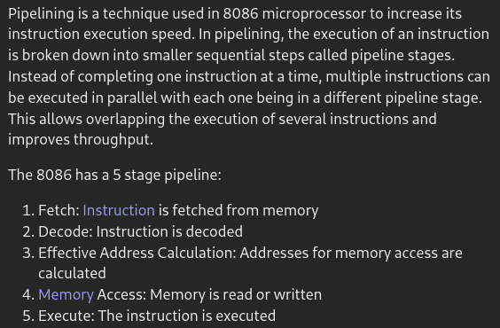
Pipelining is a technique used in computer processors to increase their processing speed, by breaking down the execution of an instruction into multiple stages or segments, and allowing different instructions to be processed simultaneously in different stages. This technique allows for more efficient use of a processor's resources, since one instruction can be executed while the next instruction is being fetched from memory and prepared for execution.

[ClaudePlus AI answer]-->

7. Write short notes on any two:

a) Interrupts of 8085
Types of interrupts in 8085:
i. TRAP ---→ highest priority
ii. RST 7.5
iii. RST 6.5
iv. RST 5.5
v. INTR ---→ lowest priority

b) Asynchronous serial transfer

c) 8 bit “W” bus
The W-Bus in a microprocessor is a 8-bit unidirectional bus that is used to transfer data from the microprocessor to memory or I/O devices. The W-Bus is also known as the write bus.

The W-Bus is activated by the WR (Write) signal. When the WR signal is high, the data on the W-Bus is transferred to the memory or I/O device that is selected by the address bus.

The W-Bus is used by instructions that write data to memory or I/O devices. Some examples of these instructions are:

MOV M,A ; This instruction copies the contents of the accumulator to the memory location specified by the address register.

2021 Spring
1 a) Define microprocessor. Write about the evolution of microprocessor.

1 b) Explain the fetch and decode cycle for NOP routing in SAP I.
NOP = No Operation (Registers and Flags are not affected)

2 a) Write SAP I program to perform as (20-36+45)₁₀. The data are stored in AH, BH, CH, and results in DH.

2 b) Describe the architectural different of SAP II with SAP I. Explain the advancement in SAP II.

3 a) Draw and explain the timing diagram for instruction LHLD.
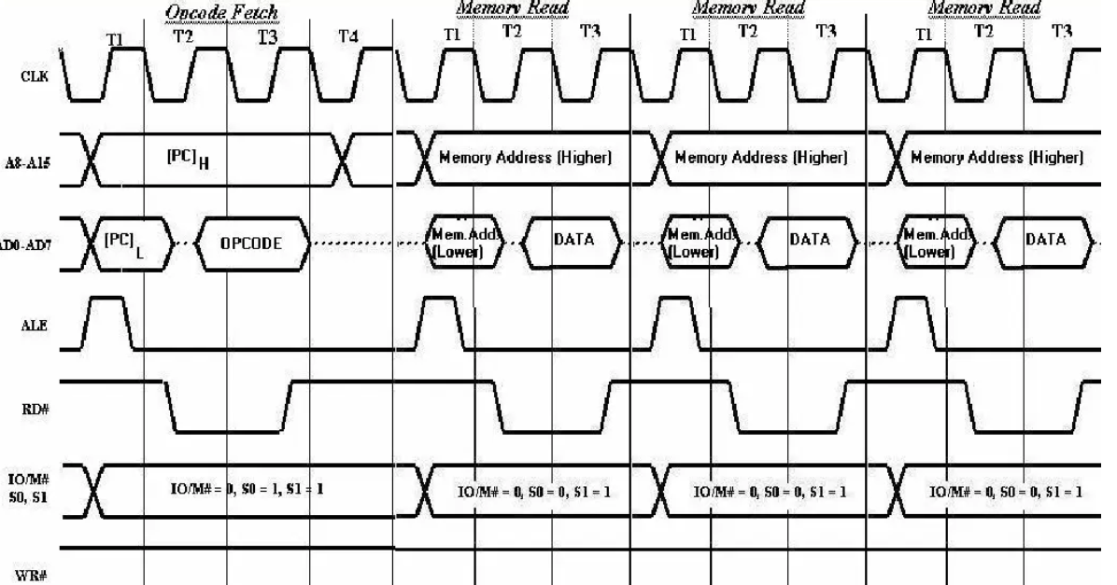

3 b) What is interrupt? Write about types of interrupt explaining each.

4 a) Write the instruction to load 65H hexadecimal number in register C and 95H in accumulator A. Display the number 65H in port 0 and 95H in port 1.

4 b) Explain DMA operation with required timing diagram.

5 a) What is interfacing? Explain the block diagram of 8255A PPI.

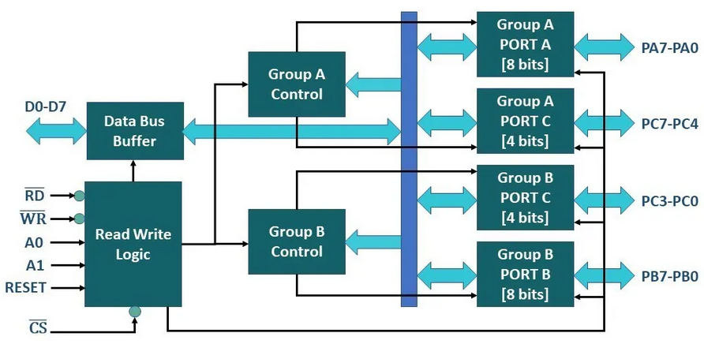

5 b) Write a program to read DIP switches from group B and display the value in group A in mode 0.

6 a) Define and explain serial and parallel communication.
6 b) Write a program in 8086 to find the square of the given number.
7. Write short notes on any two:

a) Microcontroller and Microprocessor
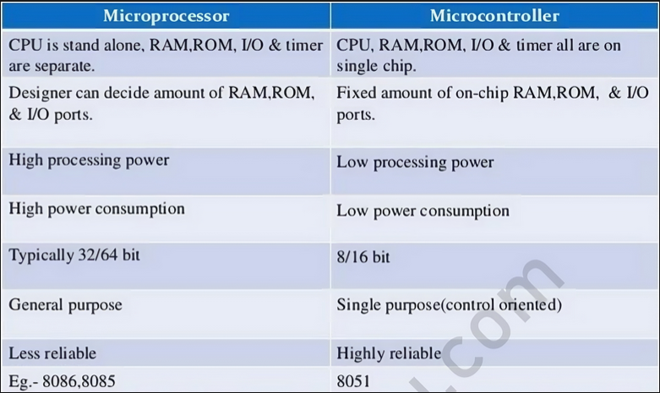

b) GPIS-IEEE 488
GPIS-IEEE 488, also known as the General Purpose Interface Standard (GPIS), is a standard for connecting and controlling instruments in a laboratory environment. It is a serial bus standard that uses a 24-pin connector. The GPIS standard defines the electrical, mechanical, and functional characteristics of the bus.

The GPIS bus can be used to connect a variety of instruments, including oscilloscopes, multimeters, and data acquisition systems. The bus can also be used to connect a computer to the instruments.

The GPIS standard defines a number of commands that can be used to control the instruments. These commands include commands to read and write data, to set the instrument's configuration, and to start and stop the instrument.

The GPIS bus is a versatile and powerful tool that can be used to connect and control a variety of instruments in a laboratory environment. It is a standard that is widely used in industry and academia.

c) RS - 232
2021 Fall
1 a) Define Stored Program Concept. Differentiate between microprocessor, microcontroller and microcomputer with examples of each.
=>
Stored program concept is a fundamental principle of computer architecture that allows a computer to store both its instructions and data in memory. This means that the computer can be programmed to perform different tasks by simply changing the instructions that are stored in memory.

The stored program concept was first proposed by John Von Neumann in the late 1940s. It was a major breakthrough in computer architecture, as it made computers much more flexible and powerful. Before the stored program concept, computers were programmed by manually setting switches or plugging in cables. This was a slow and tedious process, and it was not possible to change the program without physically rewiring the computer.

With the stored program concept, computers could be programmed by simply loading a new set of instructions into memory. This made it much easier to develop new programs and to modify existing programs. It also made computers more versatile, as they could be used for a wider variety of tasks.

Microprocessor | Microcontroller | Microcomputer
It is an integrated circuit (IC) that functions as the central processing unit (CPU) of a computer. It processes data, performs arithmetic and logical operations, and controls the flow of data through the system.  A microprocessor does not contain memory or I/O interfaces on the chip; these components must be connected externally. | It is an integrated circuit that combines a microprocessor, memory (RAM and ROM), and I/O peripherals on a single chip.  This makes it a self-contained system, ideal for embedded applications where size, cost, and power consumption are critical factors. Microcontrollers are typically used in applications that require real-time processing, control, and monitoring. | It is a small, complete computer system that includes microprocessor, memory, storage, and input/output interfaces.  Microcomputers are generally larger and more powerful than microcontrollers but less powerful than mainframes or supercomputers. They can be used for personal computing, business applications, and more.
It is expensive than microcontroller but cheaper than micro-computer. | It is cheaper than microprocessor and micro-computer. | It is the most expensive in comparison with microprocessor and microcontroller.
It needs additional pheripherals componets in order to function. Thus it cannot function on its own. | It can works as a standalone system. | It can works as a complete system.
Example:  Intel 8085,  Intel 8086 | Example:  Atmel ATmega328P (used in Arduino Uno),  Intel 8051 | Example:  Raspberry Pi 4 Model B,  Intel NUC

1 b) Draw and explain the block diagram of SAP-1 computer.
2 a) Write a program to perform the arithmetic problem (30-24+12)h.

2 b) The bits in a byte are numbered 7 to 0 (MSB to LSB). Show a program that can input a byte from port 2 and determine if bit 3 is a 1 or a 0. If the bit is a 1, the program is to load the accumulator with an ASCII Y (yes). If the bit is 0, the program should load the accumulator with an ASCII N (no). The yes or no answer is to be sent to output port 3.

; Input a byte from port 2
IN 02H

; Check if bit 3 is 1 or 0
ANI 08H ; Isolate bit 3 by ANDing with 00001000 (08H)
JZ ZERO ; If bit 3 is 0, jump to ZERO label

; Bit 3 is 1, load ASCII 'Y' (59H) into accumulator
MVI A, 59H
JMP SEND ; Jump to SEND label to output the result

ZERO: ; Bit 3 is 0, load ASCII 'N' (4EH) into accumulator
MVI A, 4EH

SEND: ; Send the result (Y or N) to output port 3
OUT 03H

; Halt the program
HLT

Cluade’s Opus AI ------>

3 a) Draw the neat and labeled timing diagram of an instruction MOV A, M. How long does it take to execute this instruction if the working clock frequency of the microprocessor is 2MHz?

3 b) What is flag in 8085 explain in detail with example.

4 a) What is the importance of DMA technique in computer system? Explain DMA transfer with suitable block diagram.
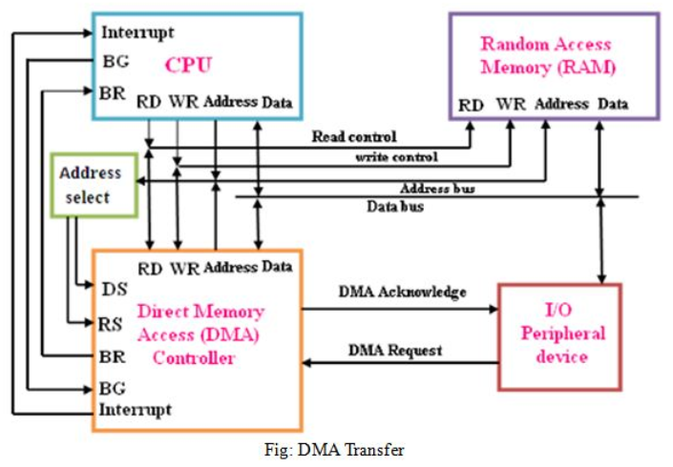

================================================================================================================================
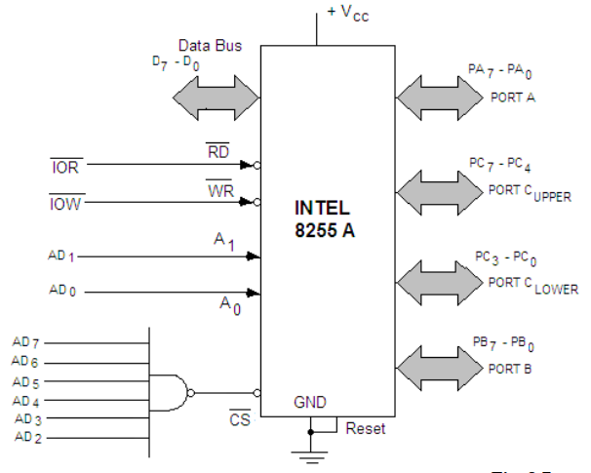
4 b) What is interfacing? Explain the block diagram of 8255A PPI.

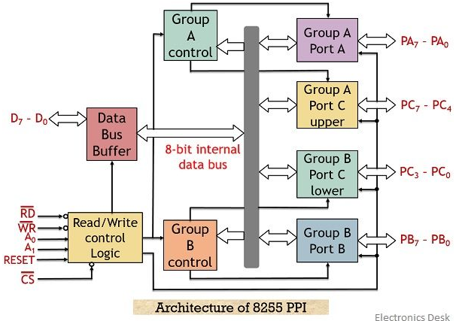

5 a) Write a program to read DIP switches from group B and display the value in group A in mode 0.
5 b)
WAP in 8085 to do following:
i. Load the number in memory location 2005H in register A.
ii. Load the number in memory location 2006H in register D.
ii. Compare the equality of contents of A and D.
iv. If two numbers are equal, display 01H otherwise display 00H at port 1.

[ YouPro AI ] [ Bard optimizing Correcting YouPro AI ]
LDA 2005H ; Load the content of memory location 2005H into A
MOV A, M ; Move the content of memory into A
LDA 2006H ; Load the content of memory location 2006H into D
MOV D, M ; Move the content of memory into D
CMP D ; Compare the content of D with A

JZ EQUAL ; Jump to label EQUAL if Zero flag is set (A equals D)
MVI A, 00H ; If not equal, move 00H into A
OUT 01H ; Output the content of A to port 1
JMP NEXT ; Jump to label NEXT
EQUAL: MVI A, 01H ; If equal, move 01H into A
OUT 01H ; Output the content of A to port 1

NEXT: HLT ; Halt the program
MVI A, 00H ; Initialize port 1 with 00H (assuming initial output)

LDA 2005H ; Load the content of memory location 2005H into A
MOV B, A ; Store the value from memory in register B
LDA 2006H ; Load the content of memory location 2006H into A
CMP B ; Compare the content of B (previously stored value) with A

JZ EQUAL ; Jump to label EQUAL if Zero flag is set (A equals B)

OUT 01H ; Output 00H to port 1 (already initialized)
JMP NEXT

EQUAL:
MVI A, 01H ; Move 01H into A
OUT 01H ; Output 01H to port 1

NEXT:
HLT ; Halt the program

6 a) What is RS 232? What is its signaling standard of RS 232? How can we use it as Null modem?
6 b) Write an 8086 ALP in DOS mode to display the string “Pokhara University” in console without using function 09H.
7. Write short notes on any two:
a. Controller/Sequencer in SAP-1 computer
b. Addressing modes in 8085
c. Bidirectional Registers

2020, Spring [Online]
Group 'A': Attempt all questions (5×10=50)

1. Malvino has designed simple computers for students to understand how a basic computer’s processor works. Have his simple computers explained the basics of microprocessor operation? Elaborate with your reasons.

2. Differentiate between an instruction and a program. The use of bi-directional register is observed in microprocessors. Explain bidirectional registers in brief using SAP II computer.

3. You are given two instructions MVI A,12H and MOV A, B. By drawing the timing diagram of these instructions, what points can you understand about the working of a processor(8085). Draw the timing diagram of any one of the instructions given above.

4. Serial communication is being used in computer systems. Is it possible to connect two terminal equipment serially? If yes, give your reasons and if no then explain your answer with facts.

5. The 8085 microprocessor suspends its current operations and execute some emergency operation. What is these operation called and explain its types and the related instructions of these operations?
OR
The DMA has different modes of operations. Between the cycle stealing mode and burst mode of DMA, which mode is better according
to your logic? Explain.

Group 'B': Problem-solving/case studies (7+7+6=20)

6. Suppose you are an assembly level programmer and you need to perform the following operations using assembly level program.
a) To find the factorial of a number stored in address C000H and store result in D000H using 8085.
b) Write a program in SAP-1 to perform (5*4-6)₁₀.
c) To reverse the given string using 8086.

2020, Fall
1 a) Explain the essential difference between:

i) Von Neumann and Harvard Architecture

Von Neumann Architecture | Harvard Architecture
Based on the stored-program computer concept. | Harvard Mark I relay-based computer model.
Same physical memory address is used for instructions and data. | Separate physical memory address is used for instructions and data.
There is common bus for data and instruction transfer. | Separate buses are used for transferring data and instruction.
The processors require two clock cycles to execute an instruction. | Processor requires only one cycle to complete an instruction.
It is cheaper to design due to its simplicity. | It is expensive to design due to its complexity.
Instruction fetches and data transfers cannot be performed at the same time. | Instruction fetches and data transfers can be performed at the same time.
This architecture basically requires less physical space to design. | This architecture comparatively requires more physical space to design.
Used in laptops, personal computers, and workstations. | Used in signal processing and micro-controllers.
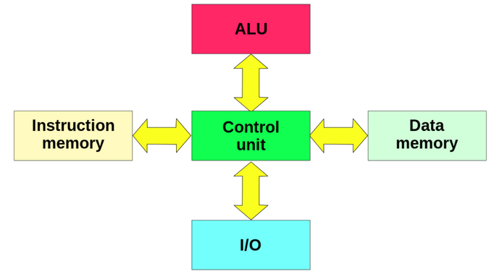 | 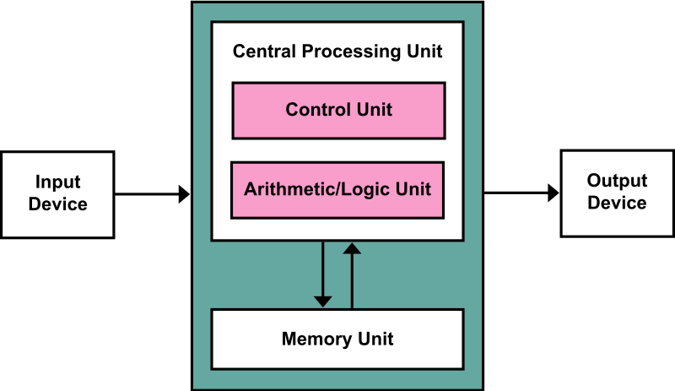

ii) Microprocessor and Microcomputer // this a very stupid question, doesn’t make sense. It should be “Microprocessor and Microcontroller”

Microprocessor | Microcomputer
A microprocessor is a central processing unit (CPU) that incorporates the functions of a computer's central processing unit (CPU) on a single integrated circuit (IC), or at most a few integrated circuits. | A microcomputer is a complete computer on a microprocessor-based integrated circuit.
It is used as part of a larger system. | It is a complete system.
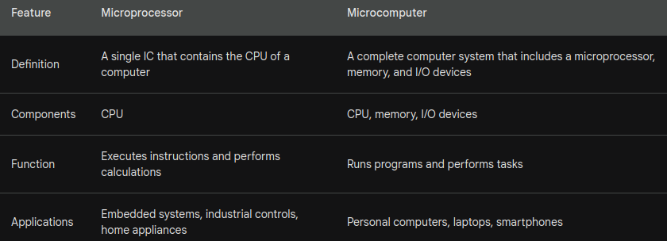

→ Bard AI

1 b) What are different types of instruction sets in SAP-I. WAP to find the square of 4 using SPI I.
==>
The different types of SAP I instruction set are enlisted below:
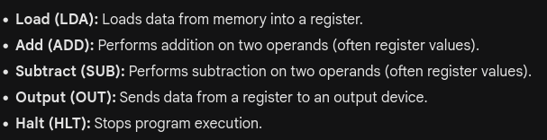

2 a) Explain the block diagram of SAP I computer architecture.
2 b) What is instruction? “SAP I is a basic computer that performs basic operations of microprocessor”. Verify this statement using 2, 4, A hexadecimal numbers.
3 a) What are the major architectural differences of SAP II computer with SAP I computer. Explain.

3 b) Define instruction cycle. Draw the neat and labeled timing diagram of an instruction LXI B, 2065H and explain.
=>
Instruction cycle, also known as machine cycle, refers to the process by which a computer system fetches a machine instruction from memory, decodes it to determine the operation it should perform, executes the operation or commands, and then stores the results back in memory.
The instruction cycle consists of four basic steps:
- Fetch - Decode - Execute - Store

4 a) Explain the addressing modes of 8085 microprocessor.

4 b) Write a program to find 1’s and 2’s complement of 8-bit number where starting address is 2000 and the number is stored at 3000 memory address and store result into 3011 and 3012 memory address.
==>
Solution:

5 a) Explain the process of DMA operation.

=====================================================================================================

5 b) Explain the bit set/reset mode of operation of 8255 programmable peripheral interface.
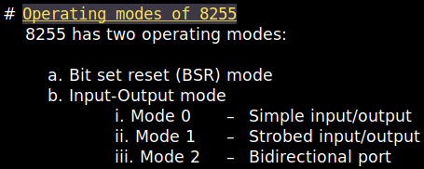
==>
8255 PPI is a general purpose programmable I/O device designed to interface the CPU with its outside world such as ADC, DAC, keyboard, mouse etc.

BSR mode
-→> If MSB of control word (i.e. D7) is 0, PPI works in BSR mode.
-→> Only port C bit is used for bit selection.
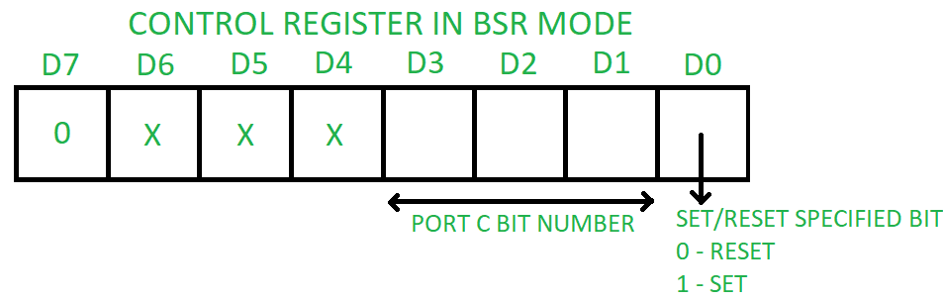
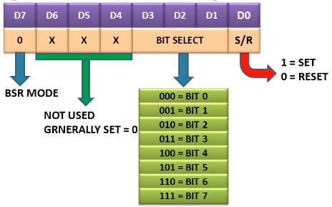

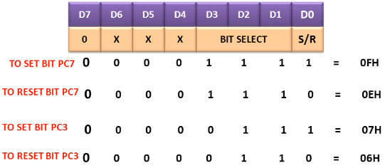

===================================================================================================
OR
Write a program to initialize 8255 PPI in the configuration given below:
i) PORT A : simple input
ii) PORT B : simple input
iii) PORT C_{L} : output
iv) PORT C_{u} : input

=======================================================================================================

6 a) What is RS232 standard? Explain Null modem Connection in brief.
==>
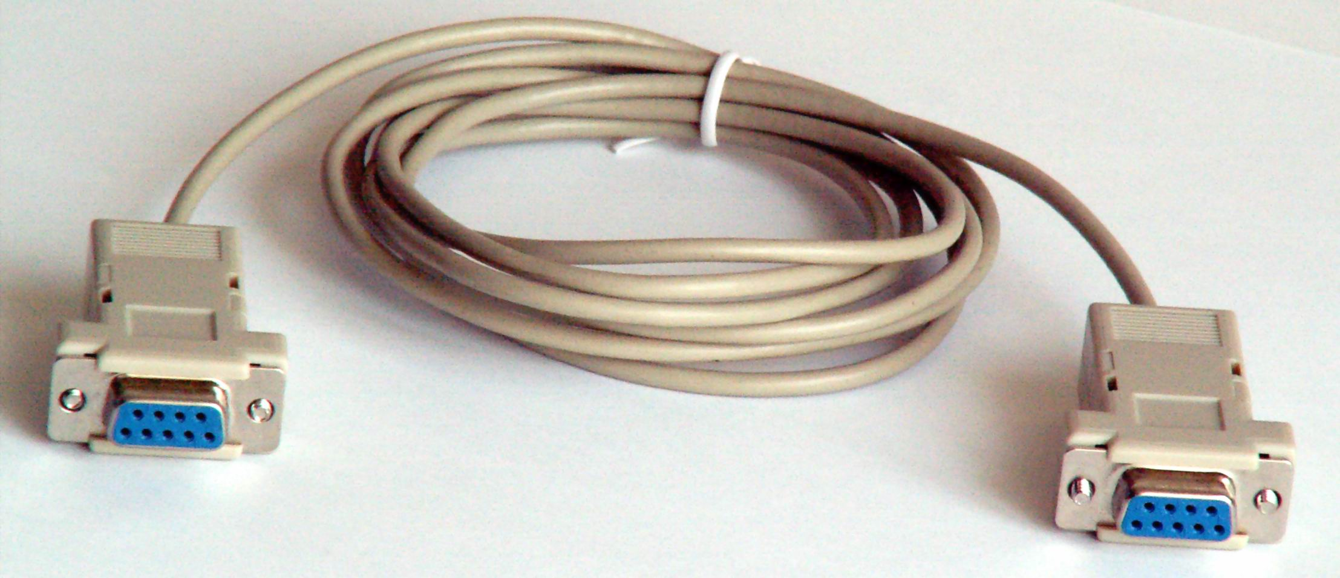
RS232 is a standard protocol used for serial communication. It is used for connecting computer and its peripheral devices to allow serial data exchange between them.

A null modem is a specially designed cable that allows a “head-to-head” connection between two nearby serial devices (computers) through their communication ports (RS-232). Having a length limitation of up to 30 feet, it is most commonly used to connect PCs within the same room for gaming and other purposes such as sending and receiving files. A null modem cable (RS-232 serial cable) is used when one needs to connect a DTE (Data Terminal Equipment) to another via their communication ports. When such a cable is employed, to establish a connection between two DTEs, both the DTEs are made to believe that, they are connected through modems. Hence the name.

A null modem is also known as a crossover cable.
There are two types of crossover cable, one has 9 pin and another has 25 pins.

A null modem uses a modem protocol with Tx (transmit) and Rx (receive) lines only suitable for serial connections.
A RS-232 serial communication interface is the standard communication channel through the data terminal equipment (DTE) — usually a personal computer — and data communications equipment (DCE), or the modem. Sending and receiving is done by separate lines, each of which has a function that enables the communication. A DTE sends data on the line which is the receiving line for the DCE. Sometimes in the absence of a DCE interface, the null modem makes the DTE interface of a PC look like a DCE interface in order to facilitate communication.

A serial data communication is directly made between two computers using the RS-232 serial cable. The basic applications of this cable are:

- Switching networks and embedded systems
- Remote Operation
- File transfer between two computers
- Providing serial administration consoles

=======================================================================================================================
.model small
.stack 100h
.data
msg db ‘I like microprocessor$’
len equ $-msg
.code
org 100h
start:
mov ax, @data
mov ds, ax
; print original string
lea dx, msg
mov ah, 9
int 21h
; reverse the string
mov si, offset msg
mov di, offset msg + len – 1
mov cx, len / 2
reverse_loop:
mov al, [si]
xchg al, [di]
mov [si], al
inc si
dec di
loop reverse_loop
; print reversed string
lea dx, msg
mov ah, 9
int 21h
; terminate program
mov ah, 4ch
int 21h
end start
6 b) Write an 8086 ALP in DOS mode to display the string “I like microprocessor” in reverse order.

==============================================================================================================================
7. Write short notes on any two:
a) Serial asynchronous communication // 1 bit at a time = Serial Asynchronous =
b) Controller/Sequencer in SAP-I computer
c) Flags of 8085

=============================================================================================================================
2018 Fall

1 a) What is microcontroller? Explain the evolution of microprocessor in addition to technological improvements of hardware.
_->
A microcontroller (aka microcontroller unit (MCU)) is a small and low-cost microcomputer, which is designed to perform the specific tasks of embedded systems like displaying microwave’s information, receiving remote signals, etc.

Evolution of microprocessor
First microprocessor was invented by Intel.
Till now, there are five generations of microprocessor.

First generation –
From 1971 to 1972 the era of the first generation came which introduced 4 bit microprocessors like Intel 4004, Intel 4040, etc. Processor clock speed reach in 740 KiloHertz (kHz).

Second generation –
The second generation marked the development of 8 bit microprocessors from 1973 to 1978. Processors like Intel 8008, Intel 8080, Motorola 6800 and 6801 etc came into existence. Processor clock speed reached 500 kHz to 3 Megahertz (MHz).

Third generation –
The third generation brought forward the 16 bit processors like Intel 8086/80186/80286 Motorola 68000 68010 etc. From 1979 to 1980 this generation used the HMOS technology. Processor clock speed reached 4 MHz to 8 MHz.

Fourth generation –
The fourth generation came into existence from 1981 to 1995. The 32 bit processors using HMOS fabrication came into existence. Intel 80386 and Mororola 68020 are some of the popular processors of this generation. 16 MHz to 66 MHz clock speed.

Fifth generation –
From 1995 till now we are in the fifth generation. 64 bit processors like Pentium, Celeron, dual, quad and octa core processors came into existence. Processor clock speed is reaching beyond 4 Gigahertz.

------------------------------------------------------------------------------------------------------------

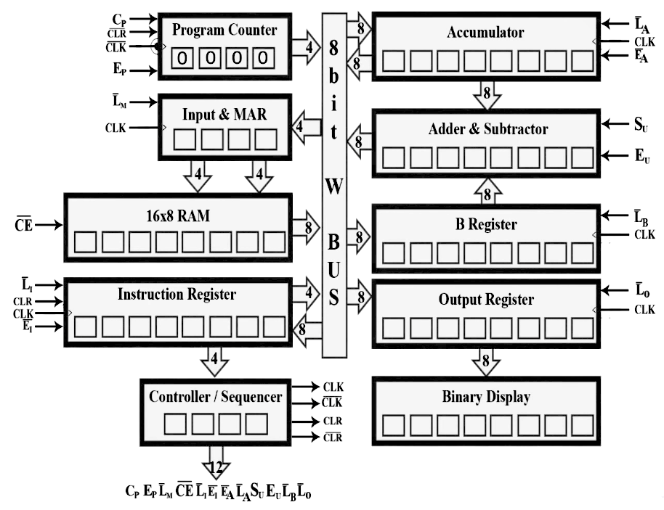
1 b) Design a block diagram of SAP-I computer. Explain the function of each components.

Trick
We can also write CON as a shortcut instead of writing all 12 control words.-------------->

------------------------------------------------------------------------------------------------------------

2 a) Write SAP-I program to perform as (20-36+45)₁₀. The data are stored in memory AH, BH, CH and result in DH memory.
==>
Sol:
Convert given value in hexadecimal format:
Note

We only have 5 instruction to write SAP I program:
Op-code
LDA - Load addressed memory into accumulator 0000
ADD - ADD address memory contents to accumulator 0001
SUB - SUB address memory content from accumulator 0010
OUT - Load address memory data into output register 1110
HLT - Stop processing 1111
20 = 14 H
36 = 24 H
45 = 2D H
Now,
Address | Mnemonics
0H | LDA AH
1H | SUB BH
2H | ADD CH
3H | OUT
4H | HLT
5H | XXX
6H | XXX
7H | XXX
8H | XXX
9H | XXX
AH | 14 H
BH | 24 H
CH | 2D H

Now, the machine language is given below:
Binary Conversion

A ---- 1010
B ---- 1011
C ---- 1100

we know,
A means 10, B means 11, C means 13
Memory Location  Hexadecimal to Binary Conversion  14 H ---- 0001 0100  24 H ---- 0010 0100  2D H ---- 0001 0110  2D H ---- 0010 1101  Here, X means Don’t Care Conditions | Op-code
0000 | 0000 1010
0001 | 0010 1011
0010 | 0001 1100
0011 | 1110 X
0100 | 1111 X
0101 | X
0110 | X
0111 | X
1000 | X
1010 | X
1011 | 0001 0100
1100 | 0010 0100
1101 | 0001 0110

========================================================================================================

2 b) Describe the architecture difference of SAP-II with SAP-I. Explain all the advancement in SAP-II.
SAP I | SAP II
Simple As Possible 1 | Simple As Possible 2
Logical Operations cannot be handled. | Logical operations can be handled.
Size of address is 8 bit. | Size of address is 16 bit.
Size of opcodes is 8 bit. | Size of opcodes is 16 bit.
Instruction have fixed length. | Instruction have variable length.
Number of instruction are comparatively lesser. | Number of instruction are comparatively greater.
No jump instruction are available to use. | Jump instructions are available to use.
Show output in binary form. | Show outputs in hexadecimal form.

Advancement in SAP-II
SAP II adds a lot of functionality to the SAP-1 hardware. Some of those advancement are enlisted below:
→ SAP 2 now can store data into RAM as well as load data.
→

=============================================================================================================
^{Note}
STA = Store Accumulator.
STA are 3 byte instruction used to store data of accumulator in memory location. It performs operation in direct addressing mode. It require only 4 machine cycle to complete:

i. Opcode fetch
ii. Memory Read (lower address)
iii. Memory Read (higher address)
iv. Memory Write
3 a) Draw the timing diagram of STA 2070H and explain it.
=>
Sol:
Addressing Mode | Flags Affected | Oprand | Cycles | T-States
Direct | None | 2070H | 4 | 13

STA ---→ 1 byte instruction
2070H ---→ 2 byte for the 16-bit memory address ( 70

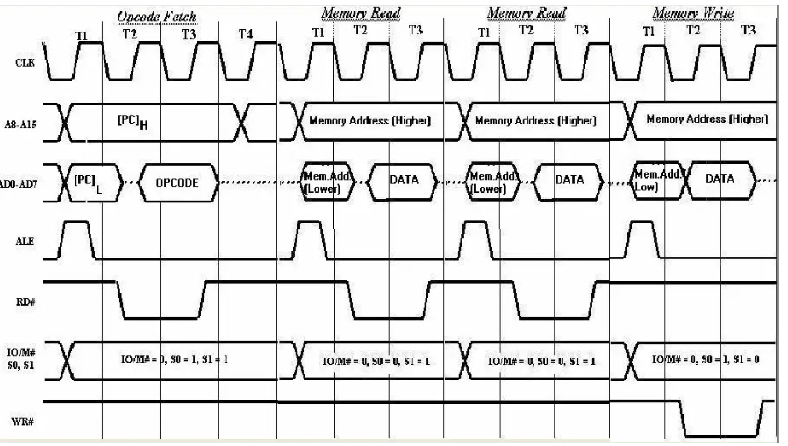
Almost every instruction starts with Opcode fetch.
--------------------------------------------------------------------------------------------------------------

3 b) Draw and explain the different blocks of 8085 microprocessor.
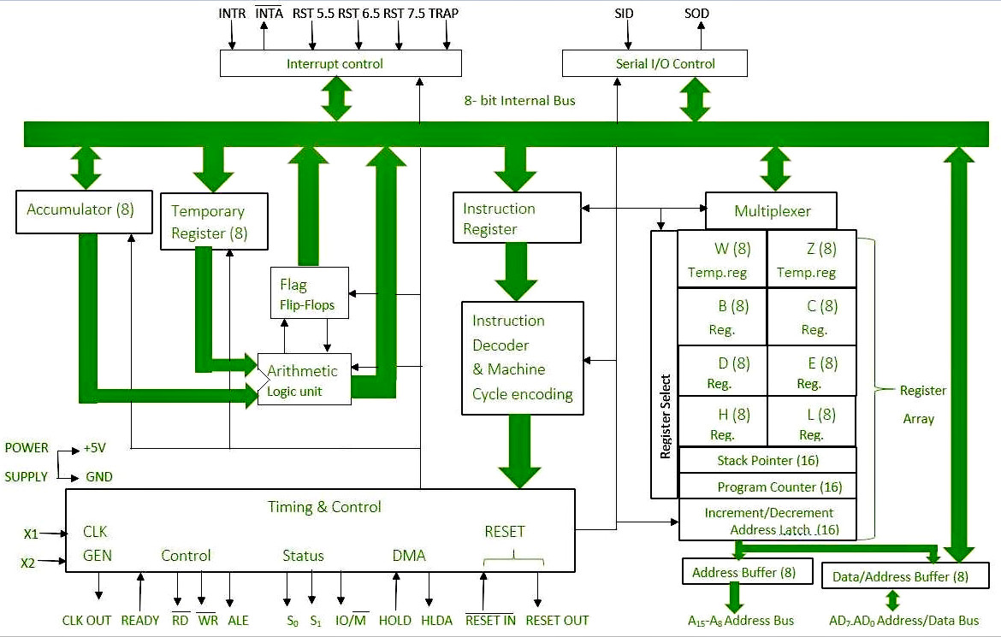

--------------------------------------------------------------------------------------------------------------

4 a) Describe the flag register of 8085 microprocessor. IF PSW is 5FH then discuss the present status of the processor.
–> Flag used in 8085 microprocessor are:
Sign flag (S)
Zero Flag (Z)
Auxiliary Carry Flag (AC)
Parity flag (P)
Carry Flag (CY)

4 b) Write a program that takes two 8 bits data from register B and C and multiply both data bytes before storing in A20BH location and in PORT2.
==>
Solution:
8 bit data means any number between -128 and 127.
Let assume,
B register holds 5 H.
C register holds 6 H.

5 a) Explain the Direct Memory Access(DMA) operation with diagram. Also write the application of DMA.

5 b) Compare 8085 microprocessor with 8086 microprocessor.
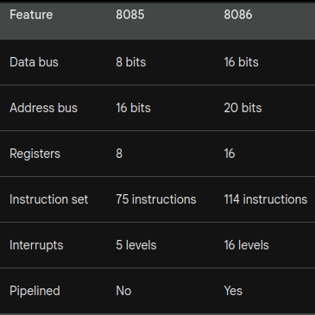

===========================================================================================================
; Initialization
MOV AL, 10000011B ; Control word: port A output (1), port B input (0), mode 1 (both)
OUT 83H, AL ; Send control word to control register (assuming 8255A is at base address 80H)

; Main Program
Main_Program:
IN AL, 81H ; Read input from port B (assuming 8255A is at base address 80H)
OUT 80H, AL ; Send the input value to port A to display on LEDs
JMP Main_Program ; Jump back to the beginning of the main program
6 a) Write a program to take input from 8 switches connected to port B of 8255A and display at 8 LEDS connected to port A such that it operates on mode 0 for input and mode 1 for output.

(Cluade Opus + Bard AI) ----->
note:
10000011B --→ 43H

so, we can write: MOV AL, 43H;

==============================================================================================================

6 b) Explain the signaling standard of RS 232C. How can we use it as Null Modem?
7. Write short notes on any two:
a) Addressing modes of 8085
b) IEEE488-1978
The IEEE-488 bus was developed to connect and control programmable instruments, and to provide a standard interface for communication between instruments from different sources. Hewlett-Packard originally developed the interfacing technique, and called it HP-IB (Hewlett-Packard Instrument Bus). The interface quickly gained popularity in the computer industry. Because the interface was so versatile, the IEEE committee renamed it GPIB (General Purpose Interface Bus). IEEE-488 allows up to 15 devices to share a single 8-bit parallel electrical bus by daisy chaining connections. The slowest device participates in control and data transfer handshakes to determine the speed of the transaction. The maximum data rate is about one Megabyte/sec in
the original standard, and about 8 Megabyte/sec with IEEE-488.1-2003 (HS-488).

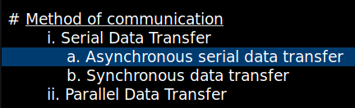
b) Asynchronous serial data transfer

============================================================================================================
Spring 2018

1 a) Define microprocessor. Explain different types of Microprocessor.
==>
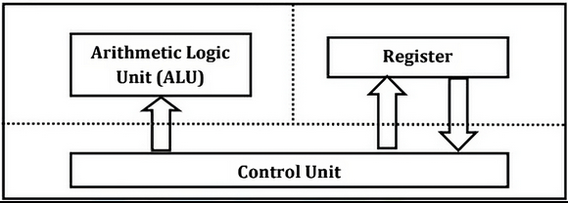Fig: Block diagram of Microprocessor
Microprocessor is a controlling unit of a micro-computer, fabricated on a small chip capable of performing ALU (Arithmetic Logical Unit) operations and communicating with the other devices connected to it.

Microprocessor consists of an ALU, register array, and a control unit.

Types of microprocessor
i. RISC ~ reduced instruction set computer
The instructions are quite simple, and hence, they execute quickly. Moreover, the instructions get complete in one clock cycle and also use a few addressing modes only. Besides, it makes use of multiple registers so that interaction with memory is less.

Examples are IBM RS6000, DEC Alpha 21064, DEC Alpha 21164, etc.

ii. CISC ~ complex instruction set computer
The instructions are in a complex form. It means that a single instruction can contain many low-level instructions. For example loading data from memory, storing data to the memory, performing basic operations, etc. Besides, we can say that a single instruction has multiple addressing modes. Furthermore, as there are many operations in single instruction they use very few registers.

Examples of CISC are Intel 386, Intel 486, Pentium, Pentium Pro, Pentium II, etc.

=============================================================================================================

1 b) Draw the SAP-I architecture and explain each block in short.
2 a) Write an ALP to perform 6-6+6+6 in SAP-I. Also write the same in machine language.
==>
ALP operation:

Address | Mnemonics
0H | LDA 7H
1H | SUB 8H
2H | ADD 9H
3H | ADD AH
4H | OUT
5H | HLT
6H | XXX
7H | 6H
8H | 6H
9H | 6H
AH | 6H
BH | XX

2 b) Explain flags and bidirectional register of SAP-II in brief.
3 a) Draw the timing diagram of 1N01H and explain it.
3 b) Draw and explain the different blocks of 8085 microprocessor.
4 a) Explain DMA with block diagram and its various operations.
4 b) Explain the different modes of operation of PPI devices 8255A.
5 a) Explain RS232C interfacing with diagram. How two computers are connected without modem?
==>
Two DTEs (computers) can be interconnected with this specially designed cable without the use of DCEs (Data Circuit-terminating Equipment) i.e. modem. A DTE is a device, which communicates with DCE, and provides data communication control functions, which is to be executed according to the link protocols, by converting the user information to signals.
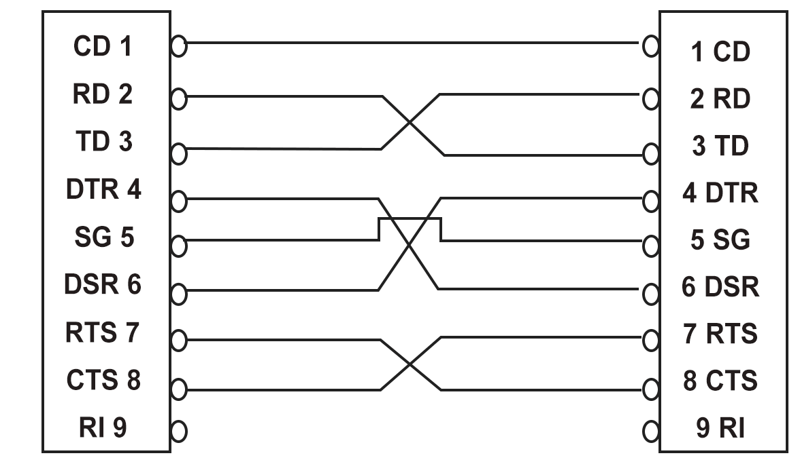
Our Computer (PC), is a DTE. DCE is a device that sits between two DTEs, and communicates with it using the standards which is primarily RS-232.

The hardware flow control between the two DTEs is done using RS-232 pin connections. First you need to identify, which type of RS-232 connector, your PC has. It could be 9-pin ports or 25 pin ports. One of the significant signals used in the connection is TD (Transmit Data) and RD (Receive Data).

TD is used by one system to indicate that it is going to transmit some data, and RD is the signal which is sent by the other system, after it receives the data. Ring Indicate (RI) port is not used in this cable.

`````````````````````````````````````````````````````````````````````````````````````````````````````````

5 b) Differentiate between Synchronous and Asynchronous Serial Communication.

Synchronous Serial Communication | Asynchronous Serial Communication
The operating clock frequency of transmitter and receiver is similar (F_{T} = F_{R}). | The operating clock frequency of transmitter and receiver is not similar.
The error can occur in data transmission are due to slight frequency difference. | Difference in frequency of transmitter and receiver can be adjusted by using stop bits after each character is transferred.
This type of data transfer is used in Microprocessor and input, output devices matches in speed. | This type of data transfer does not matches with speed.
The readiness for data transfer is not checked in input and output devices. | The readiness for data transfer is checked by CPU.
Example: Data transfer between processor and CRT terminal, key board, printer etc. | Example: Data transfer between processor and modem, audio cassettes etc.

=============================================================================================================

6 a) Write an ALP in 8085 to transfer 6-byte of data stored in memory location C000H to the new memory location starting at C050H.
6 b) Draw the block diagram of 8086 microprocessor and explain.
OR
Write a program in 8086 ALP to display the string “Rainy seasons are lovely.”
7. Write short notes on any two:
a) 8085 vs 8086
b) Evolution of microprocessor
c) Addressing modes of 8085
The way of specifying data to be operated by an instruction is called addressing mode.

Addressing modes of 8085 are:

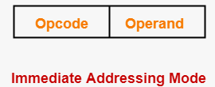
i) Immediate Addressing Mode
In this mode, the operand is specified in the instruction itself. An immediate mode instruction has an operand field rather than the address field.
For example: ADD 7H ;Add 7 to contents of accumulator. 7 is the operand here.

(In immediate addressing mode the source operand is always data. If the data is 8-bit, then the instruction will be of 2 bytes, if the data is of 16-bit then the instruction will be of 3 bytes.)

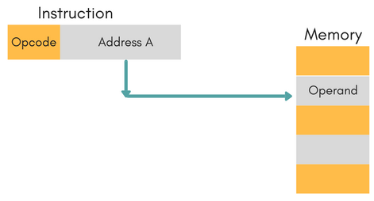
ii) Direct Addressing Mode
In this mode, effective address of operand is present in instruction itself.
For Example: ADD R1, 4000 - In this the 4000 is effective address of operand.

(In direct addressing mode, the data to be operated is available inside a memory location and that memory location is directly specified as an operand. The operand is directly available in the instruction itself.)

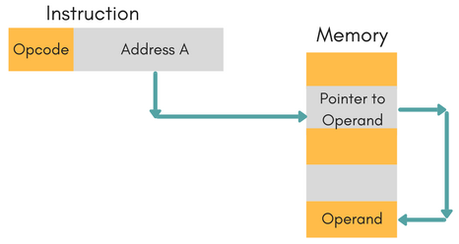
iii) Indirect Addressing Mode
In this, the address field of instruction gives the address where the effective address is stored in memory. This slows down the execution, as this includes multiple memory lookups to find the operand.

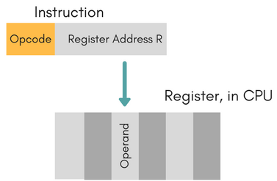
iv) Register Addressing Mode

In this mode the operand is stored in the register and this register is present in Microprocessor. The instruction has the address of the Register where the operand is stored.

(In register addressing mode, the data to be operated is available inside the register(s) and register(s) is(are) operands. Therefore the operation is performed within various registers of the microprocessor.)

v) Implied/Implicit Addressing Mode –
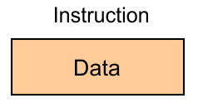
In implied/implicit addressing mode the operand is hidden and the data to be operated is available in the instruction itself.

Examples:
CMA ; finds and stores the 1’s complement of the contains of accumulator A in A
RRC ; rotate accumulator A right by one bit
RLC ; rotate accumulator A left by one bit

Spring 2017

1 a) Define bit, byte, word and instruction. Different between microprocessor and microcomputer.
1 b) Draw and explain the components of SAP-I computer.
2 a) Define controller sequence. Explain instruction cycle of SAP-1 computer.
2 b) Differentiate between SAP-I and SAP-II. Explain bi-directional register in SAP-I.
3 a) Draw the timing diagram of NOP. Discuss in brief.
3 b) With neat and block diagram explain the architecture of 8085.
4 a) Write instruction to load the 65H hexadecimal number in register C and 92H in accumulator A. Display the number 65H at PORT 0 and 92H at PORT 1.
4 b) Explain DMA operation with required timing diagram.
==>
DMA stands for Direct Memory Access. It is designed by Intel to transfer data at the fastest rate. It allows the device to transfer the data directly to/from memory without any interference of the CPU.

Using a DMA controller, the device requests the CPU to hold its data, address and control bus, so the device is free to transfer data directly to/from the memory. The DMA data transfer is initiated only after receiving HLDA signal from the CPU.

Following is the sequence of operations performed by a DMA −

→ Initially, when any device has to send data between the device and the memory, the device has to send DMA request (DRQ) to DMA controller.

→ The DMA controller sends Hold request (HRQ) to the CPU and waits for the CPU to assert the HLDA.

→ Then the microprocessor tri-states all the data bus, address bus, and control bus. The CPU leaves the control over bus and acknowledges the HOLD request through HLDA signal.

→ Now the CPU is in HOLD state and the DMA controller has to manage the operations over buses between the CPU, memory, and I/O devices.
_________________________________________________________________________________________________________________
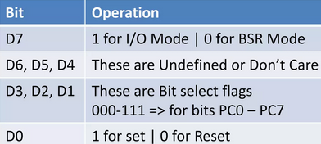
5 a) Explain the mode of operation of 8255A.
==>
8255A is a general purpose programmable I/O device designed to interface the CPU with its outside world such as ADC, DAC, keyboard, mouse etc. 8255A has two operating modes:

i. BSR Mode (Bit Set-Reset Mode)
In this mode, any of the 8-bits of port C can be set or reset depending on D0 of the control word. The bit to be set or reset is selected by bit select flags D3, D2 and D1.
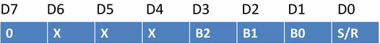

ii. Input-Output Mode
I/O operations and selected only if D7 bit of the control word register is put as 1.
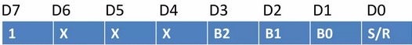
The three modes are Mode 0, Mode 1 and Mode 2.
i) Mode 0:
This is a basic or simple input/output mode, whose features are:
- Outputs are latched.
- Inputs are not latched.
- All ports (A, B, C_{U} , C_{L} ) can be programmed in either input or output mode.
- Ports don’t have handshake or interrupt capability.
- Sixteen possible input/output configurations are possible.

ii) Mode 1:
In this mode, input or outputting of data is carried out by taking the help of handshaking signals, also known as strobe signals. The basic features of this mode are:
- Ports A and B can function as 8-bit I/O ports, taking the help of pins of Port C.
- I/Ps and O/Ps are latched.
- Interrupt logic is supported.
- Handshake signals are exchanged between CPU and peripheral prior to data transfer.
- In this mode, Port C is called status port.
- There are two groups in this mode—group A and group B. They can be configured separately. Each group consists of an 8-bit port and a 4-bit port. This 4-bit port is used for handshaking in each group.

iii) Mode 2:
In this mode, Port A can be set up for bidirectional data transfer using handshake signals from Port C. Port B can be set up either in mode 0 or mode 1.
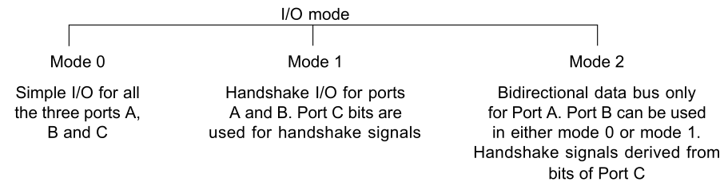

----------------------------------------------------------------------------------------------------------------------------------------------

5 b) Discuss Asynchronous Serial Communication.
Asynchronous communication is the transmission of data between two devices that are not synchronized with one another via a clocking mechanism or other technique. Data is exchanged in blocks of a fixed number of bits that are bracketed by a START and STOP bit. The term asynchronous implies the sender can initiate data transmission at any time, and the receiver must be ready to accept information when it arrives. The two devices must be operating at or nearly equal to the same frequency.

Serial Communications is the serial communications is the process of sending data one bit at a time, sequentially, over a communication channel or computer bus. Serial communication have handshaking requirements to synchronize data transfers.

The primary advantage for asynchronous serial communications is the reduced number of processor I/O pins and connecting wires or conductors.

6 a) List necessary conditions to generate INTR when PORT A of 8255 A is set up as an output port in mode 1.
6 b) Write a program to display string “Bachelor in Computer Applications”.
7. Write short notes on any two:
a) 8-bit W-bus
b) RS-232
c) I/O Write

Fall 2016

1 a) What are different types of Buses in microprocessor? Describe the achievement of microprocessor including different application area.
Different types of buses in microprocessor are:
i) Address Bus
ii) Data Bus
iii) Control Bus

These days microprocessor are like everywhere. Its in our laptop, smart TV, computers, server, mobile, camera, satellite, etc. They are tiny computer which process the data. The achievement of microprocessor including different application area are enlisted with some bullet points below:
→ Peacemaker is one of the medical equipment inserted inside the human heart. This device senses when heart is beating irregularly or too slowly. It sends a signal to your heart that makes your heart beat at the correct pace. This revolution in medical filed wouldn’t have been possible if were invented.

→

====================================================================================================================
1 b) What are different types of instruction sets in SAP-1? WAP to find the square of 4 using SAP-1.
The different types of instruction sets in SAP-1 are enlisted down below:
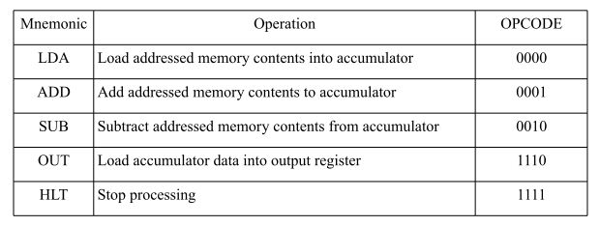

The instruction format of SAP-1 Computer is:
4
(XXXX) (XXXX)
The first four bits make the op-code while the last four bits make the operand (address).

Solution:
Address  LDA 4H ; Load the value 4 into the Accumulator (ACC)  ADD 4H ; Add the value 4 to the contents of ACC (4 + 4 = 8)  ADD 4H ; Add the value 8 to the contents of ACC (4 + 8 = 12)  ADD 4H ; Add the value 4 to contents of ACC (4 +12=16)  OUT ; Output the result stored in ACC (16, which is the square of 4)  HLT ; Halt the program execution | Mnemonics
0H | LDA 8H
1H | Add 8H
3H | Add 8H
4H | Add 8H
5H | OUT
6H | HLT
7H | XXX
8H | 4H

2 a) Compare and contrast between SAP-1 and SAP 2 including advancement of SAP2 over SAP1.
2 b) Explain the block diagram of SAP1 computer architecture.
3 a) Explain the register of SAP-II. Why bidirectional register is used?
3 b) What is timing diagram. Explain the timing diagram for MVI A.
4 a) Draw the internal architecture of 8085A microprocessor and explain each block.
4 b) What are different types of addressing modes? Explain.

====================================================================================================================
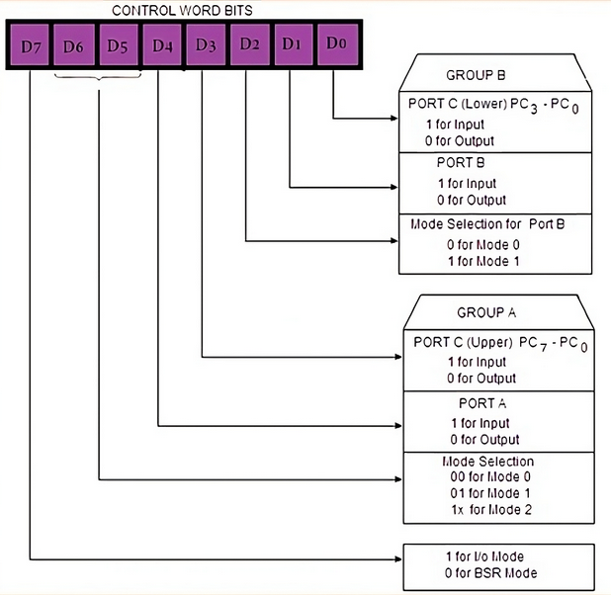
5 a) Explain the control word format of 8255 PPI.

A control word is a binary code that is used to control the operation of various components in a digital system. It is a set of binary instructions that directs or controls the operation of a microprocessor or microcontroller.

==================================================================================================================

5 b) What is RS232 standard? Explain Null modem Connection in brief.
6 a) Explain DMA with necessary diagram.
====================================================================================================================
6 b) Write a program for 8086 in MASON Assembly* to display “MICROPROCESSOR IS INTERESTING”.
.model small
.stack 100h
.data
msg db ‘MICROPROCESSOR IS INTERESTING$’
.code
main proc
mov ax, @data
mov ds, ax
mov ah, 09h ; Function 09h – Display String
mov dx, offset msg ; Offset of the string to be displayed
int 21h ; Call Interrupt 21h to display the string
mov ah, 4ch ; Function 4Ch – Exit Program
int 21h ; Call Interrupt 21h to exit program
main endp
end main

Solution:

(The code written here might not have been written “in Mason” as question asked.
MASON is a microprocessor architecture which 8086 is based on, it is not a programming language. )

======================================================================================================================

7.Write short notes on any two:

a) A/D characteristics and specifications

b) Flags in 8085
The Flag register is a Special Purpose Register. Depending upon the value of result after any arithmetic and logical operation the flag bits become set (1) or reset (0). In 8085 microprocessor, flag register consists of 8 bits and only 5 of them are useful.
The 5 flags are:
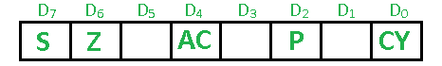

i) Sign Flag (S) – After any operation if the MSB of the result is 1, it indicates the number is negative and the sign flag becomes set, i.e. 1.
If the MSB is 0, it indicates the number is positive and the sign flag becomes reset i.e. 0.

from 00H to 7F, sign flag is 0
from 80H to FF, sign flag is 1
1- MSB is 1 (negative)
0- MSB is 0 (positive)

ii) Zero Flag (Z) – After any arithmetical or logical operation if the result is 0 (00)H, the zero flag becomes set i.e. 1, otherwise it becomes reset i.e. 0.
00H zero flag is 1.
from 01H to FFH zero flag is 0
1- zero result
0- non-zero result

iii) Auxiliary Carry Flag (AC) – This flag is used in BCD number system(0-9). If after any arithmetic or logical operation D(3) generates any carry and passes on to D(4) this flag becomes set i.e. 1, otherwise it becomes reset i.e. 0. This is the only flag register which is not accessible by the programmer.

1-carry out from bit 3 on addition or borrow into bit 3 on subtraction
0-otherwise

iv) Parity Flag (P) – If after any arithmetic or logical operation the result has even parity, an even number of 1 bits, the parity register becomes set i.e. 1, otherwise it becomes reset i.e. 0.
1-accumulator has even number of 1 bits
0-accumulator has odd parity
Example:
MVI A 05 (load 05H in register A)
This instruction will set the parity flag to 1 as the BCD code of 05H is 00000101, which contains even number of ones i.e. 2.

v) Carry Flag (CY) – Carry is generated when performing n bit operations and the result is more than n bits, then this flag becomes set i.e. 1, otherwise it becomes reset i.e. 0.
During subtraction (A-B), if A>B it becomes reset and if (A<B) it becomes set.
Carry flag is also called borrow flag.

1-carry out from MSB bit on addition or borrow into MSB bit on subtraction
0-no carry out or borrow into MSB bit

Example:

MVI A 30 (load 30H in register A)
MVI B 40 (load 40H in register B)
SUB B (A = A – B)
These set of instructions will set the carry flag to 1 as 30 – 40 generates a carry/borrow.

MVI A 40 (load 40H in register A)
MVI B 30 (load 30H in register B)
SUB B (A = A – B)
These set of instructions will reset the sign flag to 0 as 40 – 30 does not generate any carry/borrow.

_______________________________________________________________________________________________________________________________________
c) Instruction set in SAP2

